Center of Pressure and Hydrostatic Force On Submerged Bodies
Name:
ID:

Abstract
This lab report fundamentally presents the results and analysis of the Center of Pressure and Hydrostatic Force On Submerged Bodies experiment with the aim of hydrostatic pressure distribution, calculate the magnitude of the hydrostatic force on a submerged body, and calculate and verify the location of center of pressure. Additionally the results and discussion on the experiments are tabled calculations done to determine hydrostatic force and hypothetical relations established.

3. Table of contents
Table of Contents Abstract......................................................................................................................................2
List of figures.............................................................................................................................4
List of tables...............................................................................................................................5 Introduction:...............................................................................................................................6 Theory:.......................................................................................................................................6 Procedure: ..................................................................................................................................9
Result and Discussions ..............................................................................................................11
Sources of Errors: ....................................................................................................................14
Conclusion: ..............................................................................................................................15
References:...............................................................................................................................17

4. List of figures
Figure 1: experiment setup with labels of apparatus ……………………………5
Figure 2: Tilted plate……………………………………………………………………………….6
Figure3: vertical plate……………………………………………………………………………….6

List of tables
Table 1: lab results…………………………………………………………………………………………………9

Introduction
In this experiment, the hydrostatic pressure distribution is measured and observed, as well as the magnitude of the hydrostatic force on a submerged body. Lastly, we calculate and verify the location of center of pressure. In the results analysis, the experimentally determined values will be compared to theoretical calculation.
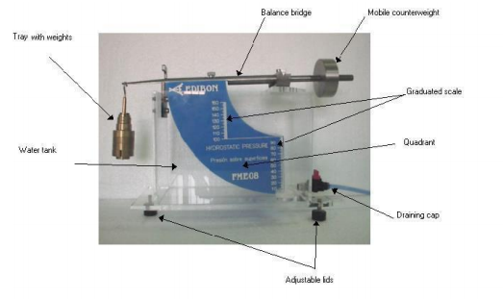
Figure 1: experiment setup with labels of apparatus

Theory
When a rectangular plate with height b and width a, is completely submerged and tilted an angle from the horizontal surface with an horizontal top edge and at a distance s from the free surface as shown below.
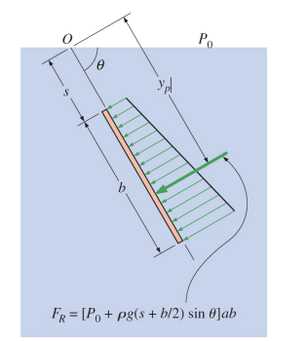
Figure 2: Tilted plate
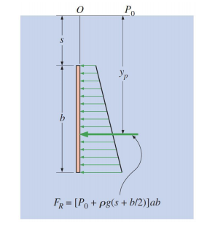
Figure3: vertical plate
The resultant hydrostatic force on the upper surface is equal to the average pressure, which is the pressure at the midpoint of the surface, times the surface area A. This is to say that;
𝐹𝑅 = 𝑃𝑐𝐴 = [𝑃𝑜 +𝜌𝑔 (𝑠 + 𝑏 2 ) 𝑠𝑖𝑛𝜃] 𝑎𝑏------------- equation 1
𝑦𝑝 = 𝑦𝑐 + 𝐼_{𝑥𝑥,𝑐} /[𝑦𝑐 + 𝑃𝑜 𝜌𝑔sin𝜃 ] 𝐴-----------------equation 2
Directly beneath the centraoid of the plate, the force acts at a vertical distance of h_{p}=y_{p}sin θ. At this point equation 2 translates to;
𝑦_{𝑝} = 𝑠 + 𝑏/2 + {(𝑎𝑏³/12) /[𝑠+ 𝑏/2 + (𝑃𝑜 /𝜌𝑔 𝑠𝑖𝑛 𝜃) ]𝑎𝑏}
𝑦_{𝑝} = 𝑠 + 𝑏/2 + {𝑏² /12/[𝑠+ 𝑏/2 + (𝑃𝑜/𝜌𝑔 𝑠𝑖𝑛 𝜃) ]------------- equation 3
For a plate with an horizontal edge that is completely submerged (𝜃=90 degrees), the hydrostatic force is obtained by setting sin 90deg=1 as shown above in fig. 3, is given by;
𝐹𝑅 = [𝑃_{𝑜} + 𝜌𝑔 (𝑠 + 𝑏/2 )] 𝑎𝑏------------------- equation 4

Procedure
During the experiment, the necessary calibrations on the rig were done and then the setup placed on an horizontal surface and slight adjustments using the adjustable lids to ensure that it was levelled. To level off the balance bridge, an empty hook was attached to a counter weight. The gate valve was then closed and the we filled the tank until the rectangular plate on the quadrant was fully submerged. The water level was higher than the height of the rectangular surface. Aimed at balancing out the balance bridge with the amount of water by weights were added to the hook and the balance bridge was restored to its balance position. The water depth was taken and recorded for use in the calculation of hydrostatic force acting on the vertical plate. A moment balance on the pivot of the moving arm was performed to determine the point of action of the hydrostatic force. The point of action of the hydrostatic force was calculated using equation 3and compared the value experimentally obtained from the previous step. The steps were repeated for different water levels.

Results and discussions
b(m) | Mass (kg) | F_{R}(N) | Y_{p,th}(m) | L(m) | α (m) | Y_{p,Exp}(m) | Error%
0.1 | 0.202 | 3.4300 | 0.0667 | 0.5642 | 0.3642 | 0.4642 | 5.96
0.09 | 0.162 | 2.7783 | 0.0600 | 0.4525 | 0.2525 | 0.3425 | 4.z71
0.08 | 0.132 | 2.1952 | 0.0533 | 0.3687 | 0.1687 | 0.2487 | 3.67
0.07 | 0.102 | 1.6807 | 0.0467 | 0.2849 | 0.0849 | 0.1549 | 2.32
0.06 | 0.077 | 1.2348 | 0.0400 | 0.2151 | 0.0151 | 0.0751 | 8.78
Table 1: lab results
Calculations
FR in N
FR= pgab²/2
a= 0.07m, p=1000kg/m^3 p= 9.8 m/s2
At b=0.1m; F_{R}= (1000 kg/m^3 *9.8m/s^2*0.07m *0.1^2)/2 =3.4300N
At b=0.09m; F_{R}= (1000 kg/m^3 *9.8m/s^2*0.07m *0.09^2)/2 =2.7783N
At b=0.08m; F_{R}= (1000 kg/m^3 *9.8m/s^2*0.07m 0.08^2)/2 =2.1952N
At b=0.07m; F_{R}= (1000 kg/m^3 *9.8m/s^2*0.07m *0.07^2)/2 =1.6807N
At b=0.06m F_{R}= (1000 kg/m^3 *9.8m/s^2*0.07m *0.06^2)/2 =1.2348N
Y_{p,th}(m); y=2b/3
At b=0.1m; y_{p,th}=2*0.1/3=0.0667m

At b=0.09m; y_{p,th}=2*0.09/3= 0.0600m
At b=0.08m; y_{p,th}=2*0.08/3=0.0533m
At b=0.07m; y_{p,th}=2*0.07/3=0.0467m
At b=0.06m; y_{p,th}=2*0.06/3=0.0400m
L(m); L=0.285mg/FR
At m=0.202kg; L=0. 285*0.202kg*9.8m/s^2= 0.5642m
At m=0.162kg; L=0. 285*0.162kg *9.8 m/s^2=0.4525m
At m=0.132kg; L=0. 285*0.132kg *9.8 m/s^2=0.3687m
At m=0.102kg; L=0. 285*0.102kg *9.8 m/s^2=0.2849m
At m =0.077kg; L=0. 285*0.077kg*9.8 m/s^2=0.2151m
α (m) = 0.2-L
For b=0.1m; α (m) = 0.2-0.5642=-0.3642m
For b=0.09m; α (m) = 0.2-0.4525 =0-0.2525m
For b=0.08m; α (m) = 0.2-0.3687 =-0.1687m
For b=0.07m; α (m) = 0.2-0.2849=0.0849m
For b=0.06m; α (m) = 0.2-0.2151=0.0151m
Y_{p,Exp}(m)= b- α
For b=0.1m Y_{p,Exp} =0.1--0.3642m=0.4642m
For b=0.09m Y_{p,Exp} =0.09m--0.2525m=0.3425m
For b=0.08m Y_{p,Exp} =0.08m--0.1687m=0.2487m
For b=0.07m Y_{p,Exp} =0.07m-0.0849m=0.1549m
For b=0.06m Y_{p,Exp} =0.06m-0.0151m=0.0751m
Error%= (Experimental- Theoretical)/Theoretical*100
=(0.4642m-0.0667m)/ 0.0667m*100=5.96%
=(0.3425-0.0600)/0.0600m*100=4.71%
=(0.2487-0.0533)/0.05333m*100= 3.67%
=(0.1549-0.0467)/0.0467m*100= 2.32%
=0.0751-0.0400/ 0.0751m*100=8.78%
Analysis
`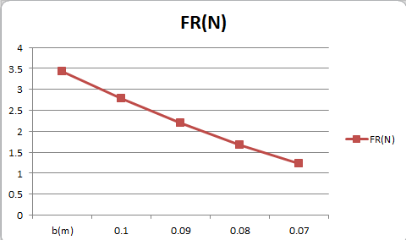

10. Sources of error
The sources of error include inherent limitation of measuring devices used. The rulers and the initial labelling’s.

Conclusion
The hydrostatic pressure force acting on the rectangular plate. The equivalent force will act in a direction perpendicular to the surface through which it acts. By definition, the centre of pressure will lie on this equivalent forces line of action.

References
Jasim, N. A., & Shamkhi, M. S. (2020). The design of the center of pressure apparatus with demonstration. Cogent Engineering, 7(1), 1843225.

